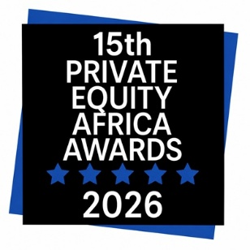

Private Equity Africa Awards

Supplementary Information

Entries must be attached to your online entry by the deadline.

Please read the Rules and Conditions before entering.

Queries? Please email: awards@peafricagroup.com

ABOUT THIS FORM

Single Fund Award

Please use this form to provide the additional information required by judges:

- Verify the single fund worked on in the year under consideration

- Explain why you should win the award

Please indicate the total number of pages in your submitted entry [ ]

Special Note: To be shortlisted for the award, the entry has to include the name and title of the person designated to receive the award, if won. The person will have to be available to attend the Awards Gala Dinner. Kindly note the Private Equity Africa Awards are only collected by senior members of the team, at Partner & Director level or above.

A: ENTRY INFORMATION

Your Company Name
Award Nominee Company Name
Award Nominee Full Name
(If Individual Award)
Your Name
Your Email Address

B: AWARDS CATEGORY

- Investor Award [Subcategories: Fund of the Year/ New Fund Strategy]

- Advisor Award [Subcategories: Single Fund Advisory]

- Individual Award [Subcategories: Single Fundraising Achievement]

C: FUND DETAILS

All responses should be factual and will be treated as confidential

Fund name

D: ADDITIONAL DETAILS

Please provide additional details that may aid in decision making. Please note that the judges have limited time for each entry. As such text exceeding the word count will automatically be cut off.

Fund target

Fund milestones reached
(Launch, or First, Interim or Final Close)

Amount raised so far
Target countries
Fund unique aspects
(Maximum 200 words)

Key Issues Fund is Addressing
(Maximum 200 words)

Impact strategy
(Development & Social)
(Maximum 200 words)

Challenges overcome to
set up / raise or close fund
(Maximum 200 words)

Why should you win this award?
(Maximum 200 words)

