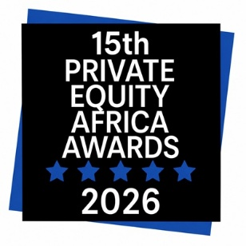

Private Equity Africa Awards

Supplementary Information

Entries must be attached to your online entry by the deadline.

Please read the Rules and Conditions before entering.

Queries? Please email: awards@peafricagroup.com

ABOUT THIS FORM

Portfolio Company of the Year

Please use this form to provide the additional information required by judges.

- Verify portfolio company achievements during the period of investment.

- Explain why you should win the award

Please indicate the total number of pages in your submitted entry [ ]

Special Note: To be shortlisted for the award, the entry has to include the name and title of the person designated to receive the award, if won. The person will have to be available to attend the Awards Gala Dinner. Kindly note the Private Equity Africa Awards are only collected by senior members of the team, at Partner & Director level or above.

A: AWARD SEGMENT

Please tick the relevant box to select the award being entered

A single portfolio may be entered for more than one award

- Social Impact

- Innovation

- Development Impact

- Improvement

B: NOMINEE DETAILS

Investor name

C: DEAL DETAILS

All responses should be factual and will be treated as confidential

Portfolio Company name

D: ACHIEVEMENTS SINCE INVESTMENT

Please provide additional details that may aid in decision-making

(Each response must be a maximum of 200 words) Please note that the judges have limited time for each entry. As such text exceeding the word count will automatically be cut off.

D1: Improvement
Financial and product improvement
D2: Development Impact
Impact on country or region
D3: Social Impact
CSR implementations
D4: Innovation
Services introduced & Innovations
Why should you win this award?

